Summary of Keith Armstrong’s brief presentation:
“So, you thought you knew how to do grounding?”
— or —
“Shocking news about grounding”
for the C-PRAV/WE seminars in Australia and NZ October 2025
We each think we know about electronic ‘grounding’ and how to do it, but the lack of a common and correct understanding of it has blighted the electronics industry for 50+ years, to my personal knowledge.
It is stuck in the 1950s, and wastes huge amounts of time & cost (probably billions of US$ annually) because of how we were first taught about electricity and circuits.^{[1]}
The result, is that designers often use the word ‘ground’ as a magic wand, as if simply naming a circuit node as ‘ground’ (or ‘earth’, chassis, deck, frame, etc.,) is enough to make it behave as a zero-impedance sink that can absorb an infinite amount of RF noise current! (Which is, of course, impossible.)
Different designers often specify different requirements for ‘grounds’ (etc….) – confusing their design teams and assembly personnel. Then, every few years when the frequencies we design with, and suffer as noise, jumps ever-higher, they have to discover the hard way^{[2]} that they should have specified them differently in the first place.
Prompt an AI with “What is a ground for an electronic circuit?” and you will get competent descriptions of several different types of grounds, e.g.: voltage reference, current return, safety, earth, common, signal, RF, EMC, and more. Some of them appear to contradict others.
But because operational and noise frequencies are continually increasing, the whole electronics industry is constantly playing catch-up; which means the information used to train AIs is out of date, so they can’t help.
For reducing time-to-market, optimising material costs, easing assembly, reducing costs of manufacture and warranty costs, we need a single set of future-proof design rules that covers every type of grounding from DC to TeraHertz.
That is what my presentation describes, using easy visualisations, plain English, and maths that only needs our mobile phone calculators.

^{[1]} See Daniel Beeker’s “Billion Dollar Mistake” for more on this educational error: https://pcdandf.com/pcdesign/index.php/editorial/menu-features/16269-the-billion-dollar-mistake
^{[2]} By having to investigate functional / EMC test failures when the project has run out of time and money. (Been there, done that, got the physical and mental scars to prove it.)

Using LTspice in EMC Design
Dr. Marco Klingler will be giving a presentation in Melbourne and Brisbane, October 6th and 9th, on how a simple electric circuit simulation tool such as LTspice can be used to design and pre-validate a simple EMC LC filter based on a WE-SD Rod Core Choke 744711010 and two WCAP-FTBP Film Capacitor 890273327007CS to meet the conducted emission requirements on table (see figures below).
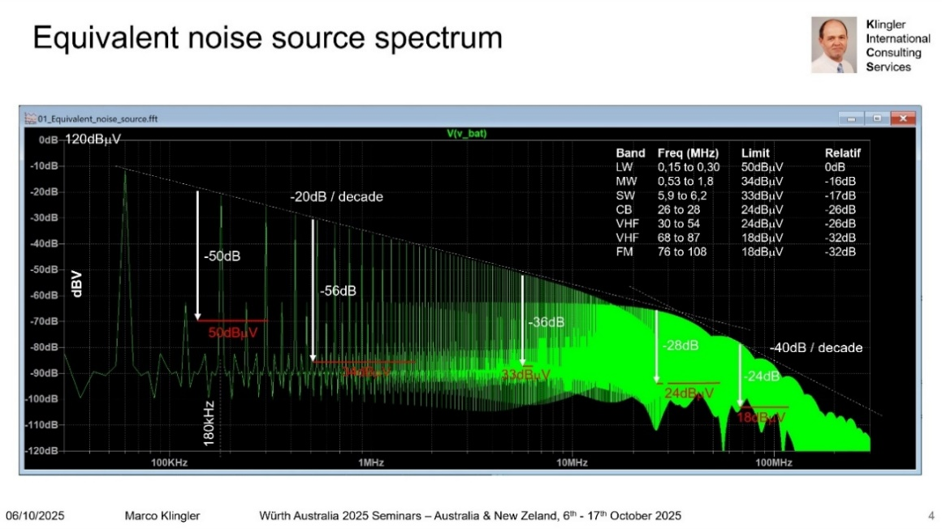
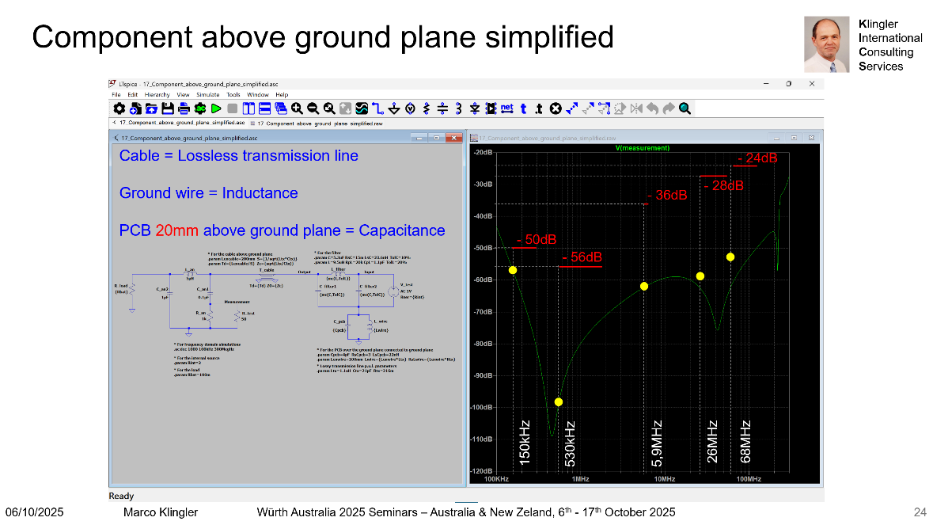
Dr. Klingler will also be based in Australia the entire October and November for those who would like to go further and make a real step towards numerical simulation. He will be able to provide help on the use of numerical simulation tools throughout the different phases of the development of your products. Assistance can be brought to you by using tools already available in your company, or more or less sophisticated tools ranging from simple circuit simulators (e.g. LTspice, Qspice, PSpice, etc.) to full 3D electromagnetic solves available by software vendors (e.g. CST, EMCoS, FEKO, HFSS, etc.). He can also offer guidance on how to implement cost-effective numerical simulation activities in your company’s process. Many industrial examples I have experienced can be downloaded <here>.

Compliance and Product Regulatory Approvals
- to Sell Your Products in AU/NZ & Globally
You have a great innovative idea, you start building the prototypes, project has now Kicked off. On the journey of Concept to Reality –Design, Develop, Test & Validate.
Several things to consider during this pathway……critical for the project’s progress
- What Standards to apply?
- What Regulations apply?
- What Testing is needed? What if your product Passes or what if your product Fails the tests?
- What markets you want to sell to? Hence, what Certifications are required?
- Outdoor use of your product, have you considered Thermal & Humidity testing, Water Ingress testing, Dust tolerance, UV protection.
- Product connects to the internet, does it comply with Cyber Security?
PLAN TO PASS - FAIL TO LEARN
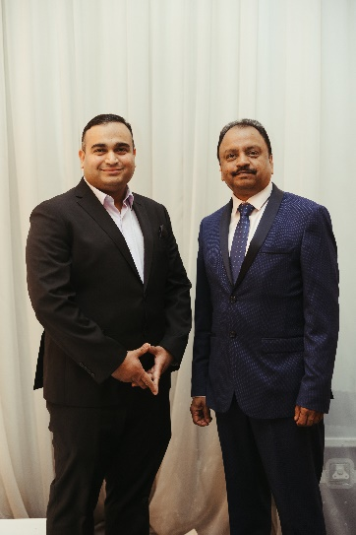
This session will cover how to ensure that the product is compliant with mandatory regulations, which countries to market and sell your product, standards you need to test your product to, how you should configure your products for testing, what regulations apply for your product and after testing, how to complete the approvals? At C-PRAV, we specialize in and have guided hundreds of various manufacturers to sell their products globally.

PRAVEEN RAO Anup Aundhakar
CEO, Technical Director Operation Director
C-PRAV Group C-PRAV Australia
Praveen@c-prav.com Anup@C-PRAV.com
+61 412 258 952 +61 478 653 461

------------------------------------------------------------------------------------------------------------------------

EMC with EMC
(Electromagnetic Compatibility with Electromechanical Connections)
Presentation By Wurth Electronics

In this seminar, we will discuss about mitigating potential EMC issues with board to board and wire to board connections. We will also explore on grounding, coupling path and how to employ proper shielding.

